Just Cause bugs

By Fredrick Östlund



**Game physics: Poor collision detection 1**

Poor collision detection when the player walks on containers. The player can walk in midair, maybe it is the invisible bounding box [http://www.morrowland.com/apron/article/gl/boundingbox/index.php] that is too big for the containers

1. In the western Military base, where the first “Mucho dirty official” tries to escape to, there are some containers.

2. Jump on the containers, pressing Space-button

3. Climb to the top of the containers

4. Go to the gap between the two highest containers

5. Walk between the containers in midair

6. One can also walk in midair on the edge of the containers



**Game physics: level crossing gate bar 2**

The level crossing gate doesn’t have realistic physics, or “weight”. The player can play soccer with it, and the bar should possibly be much heavier and not behave as a gas-filled balloon or a ball of some sort. It looks like it’s made of wood and concrete. This could be a feature of the game, but I doubt it. [See movie clip: bug2JustCause_F_Ostlund]

1. Hi-jack a vehicle.

2. Drive to the western Military base

3. Hit the crossing gate, so it breaks and falls to the ground

4. Exit vehicle (and probably deal with the soldiers/mission before proceeding)

5. Go/run to the bar on the ground

6. The player should now be able to “play” with it as a ball.

**AI problem: Boss sporadically inactive 3**

When the Player meets the second of the bosses “Mucho dirty official” and is about to assassinate him, the boss doesn’t fight back properly or is inactive sporadically. The player doesn’t seems to gain enough “aggro" [http://en.wikipedia.org/wiki/Hate_(video_gaming)] all the time or if it's the pillar or other static stuff that confuses the AI? Anyway, if one is under fire, one is unlikely to just stand still and contemplate from time to time. [See movie clips bug3aJustCauseDemo_F_Ostlund.MP4 and bug3bJustCauseDemo_F_Ostlund.MP4].

1. Finish the first mission, and accept the second mission (talk to the guerrilla man).

2. Go to the second military base, and deal with the soldiers and barriers.

3. Attack the boss.

4. The “Mucho dirty official” no. #2 will only attack the player sporadically. This seems mostly happen when he is near the house pillars’ and the player is behind those, see movie clip.

**Graphics: Machine Gun in tower graphical problem 4**

In the western military base there is at least one machine gun tower. All of the machine guns seem to be missing the joint between the gun and the hull. This might not be a bug, but a graphics style, but it looks weird that the gun “floats” in the air. (See pictures bug4a_JustCause_F_Ostlund.jpg and bug4b_JustCause_F_Ostlund.jpg]

1. In the western military camp there are some machine gun towers (possibly kill the soldiers and finish the mission before)

2. Climb the ladder (possibly kill the soldier in the tower)

3. Look at the machine gun on its hull.

**Design issue: Late info to the player 5**

In the beginning, when the player is parachuting, most of the time some info boxes appears. Both the one on how to “Land on vehicles” and “how to Land” is displayed too late. The player has often already landed, or died, so the info is either unnecessary or the player can never benefit by this information. The info on how to land is showed in the left hand corner of the screen, but this can easily be missed, and is not as attention-demanding as the info boxes. [See picture bug5a_JustCause_F_Ostlund and bug5b_JustCause_F_Ostlund.jpg]

1. Start the game/demo

2. Land using E-button (or do nothing, but then will the player die)

3. The player survives using E-button (the parachute) or dies doing nothing.

4. The info box should display (sometimes it never even does that), after the player has landed (safe).

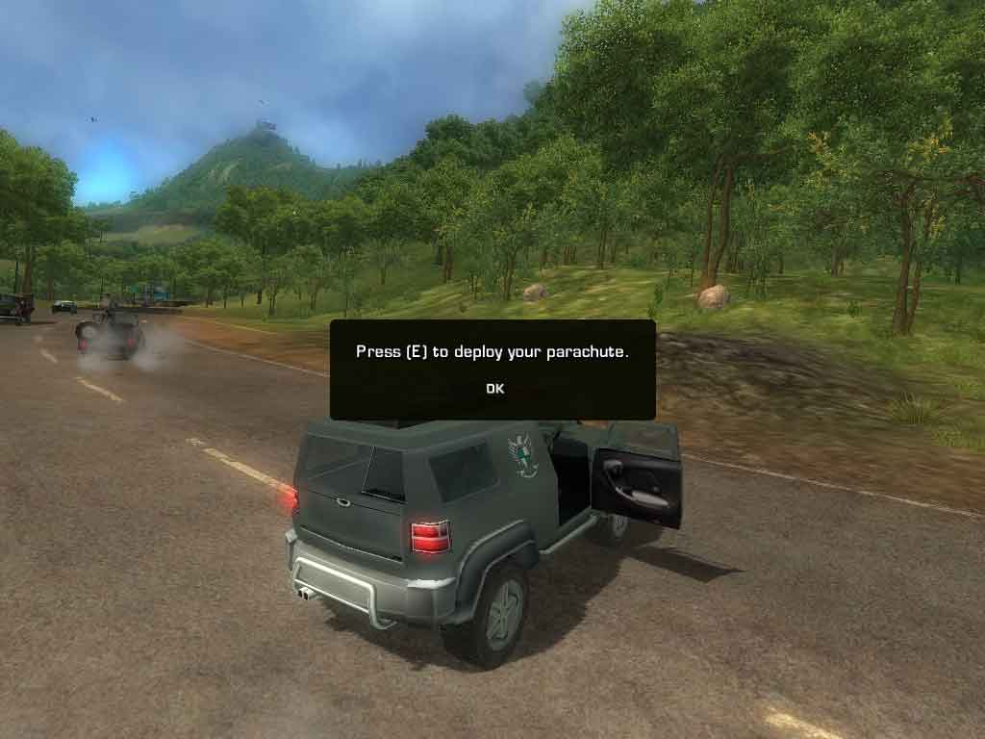

**Design/other issue: Disappearing jeep.**

When the player has finished the first mission and is about to meet up and speak with the guerrilla the jeep sometimes disappears. The player must of course have brought a jeep (or perhaps another vehicle) to the meeting. This doesn’t always occur. If the jeep doesn’t disappear the player receives a soldier’s aide (one that can handle the mounted gun). [See movie clip bug6_JustCause_F_Ostlund]

1. Finish the first mission.

2. Hi-jack a jeep with a mounted gun on it.

3. Go to the guerrilla meeting.

4. Stand in the sight of the jeep and in position so the player can speak to the guerrilla man.

5. Press “E” to talk to the guerrilla man.

6. The jeep mysteriously disappears.

**Design issue/AI: Overconfident NPC**

In the western military base after having finished the first mission some of the soldiers in the camp don’t seem to care about the player or is overly bold. Even if one has killed there comrades and blown up stuff they don’t attack, they just delivers some one-liners. Not even if the player shoots some of the soldiers in the leg, on the ground besides them etc. they will attack. If this is a game feature this makes the game less fun, because one cares less, at least I think so. If the enemy doesn’t presents a danger, why should the player bother? But this could be AI glitch of some kind? [See movie clip: bug7_JustCause_F_Ostlund]

1. Finish the first mission.

2. Go to, if one not already is there, the western Military base.

3. (If this is not already is done) attack the soldiers (and maybe blow up stuff/ behave badly)

4. Some of the soldiers will not attack, just talk to you.

5. Shoot some of them in the leg etc.

6. Some of them won’t attack you even after this.